

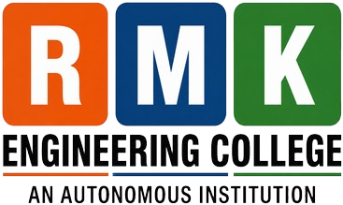 | R.M.K. ENGINEERING COLLEGE  (An Autonomous Institution) | Accredited by NAAC with ‘A+’ Grade  R.S.M. Nagar, Kavaraipettai – 601 206, Gummidipoondi Taluk, Thiruvallur District | 

DEPARTMENT OF COMPUTER SCIENCE AND ENGINEERING

COMPUTER SOCIETY OF INDIA (CSI) STUDENT CHAPTER
P O S T - E V E N T R E P O R T
INAUGURATION OF
CSE STUDENT’S ASSOCIATION & CSI-STUDENT’S CHAPTER

📅 Date: Wednesday, 12 August 2026 | 📍 Venue: RJ Block Seminar Hall
⏰ Time: 10:30 a.m. | 🎓 Academic Year: 2026–2027
🏆 Chief Guest: Shri. Pravin Bhamare | 🏢 Global Delivery Head, TCS, India
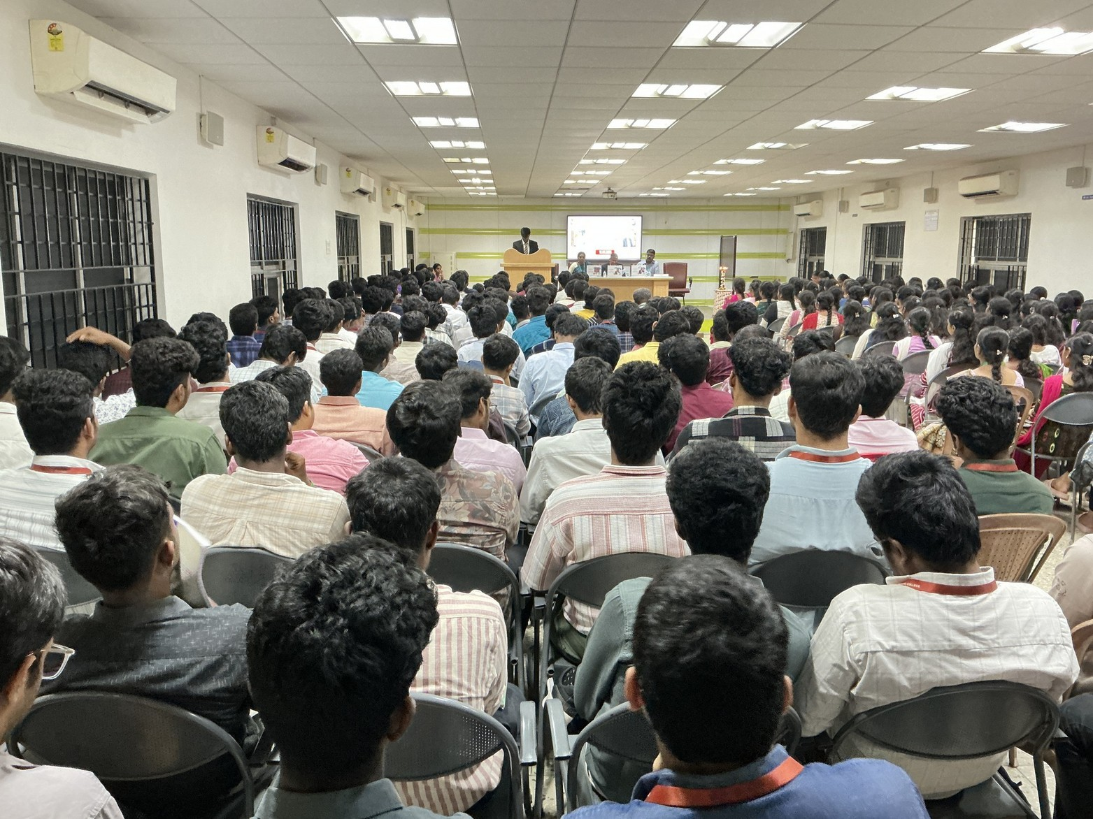

✦ INAUGURATION CEREMONY — DAIS & DIGNITARIES ✦
Dignitaries on dais during the inauguration ceremony at RJ Block Seminar Hall, RMKEC



POST- EVENT REPORT
Inauguration of CSE Student’s Association & CSI-Student’s Chapter | 2026–2027
📋 EVENT DETAILS

Name of Event | Inauguration of CSE Student’s Association & CSI-Student’s Chapter
Organizing Department | Department of Computer Science and Engineering
Institution | R.M.K. Engineering College (An Autonomous Institution)
Date & Time | Wednesday, 12 August 2026 | 10:30 a.m.
Venue | RJ Block Seminar Hall, RMKEC
Academic Year | 2026–2027
Chief Guest | Shri. Pravin Bhamare, Global Delivery Head, Tata Consultancy Services (TCS), India
Presidential Address | Vidya Ratna Shri. R. S. Munirathinam, Founder-Chairman, R.M.K. Group of Institutions
Felicitations | Management Trustees, Advisors, Principal, and Head of Department
Target Audience | Students of Computer Science and Engineering, Faculty Members & CSI Members
Mode of Event | Offline / In-Person
📖 ABOUT THE EVENT
The Department of Computer Science and Engineering at R.M.K. Engineering College (An Autonomous Institution) formally conducted the Inauguration of the CSE Student’s Association and CSI-Student’s Chapter for the Academic Year 2026–2027 on Wednesday, 12 August 2026, commencing at 10:30 a.m. at the RJ Block Seminar Hall. The event was organized to formally launch the calendar of departmental co-curricular and professional chapter activities for the student community.
The Computer Society of India (CSI) is one of India’s established professional bodies for computing professionals and students. The CSI Student Chapter at R.M.K. Engineering College, operating in conjunction with the CSE Student’s Association, provides a dedicated institutional forum for students to enhance their technical knowledge, engage in peer collaboration, and participate in organized technical initiatives throughout the academic year.
The inaugural ceremony brought together management trustees, institutional leadership, faculty members, and student representatives. Shri. Pravin Bhamare, Global Delivery Head, Tata Consultancy Services (TCS), India, graced the function as the Chief Guest, formally inaugurating both bodies and delivering the inaugural address.

R.M.K. Engineering College (Autonomous) | Department of CSE | CSI Student Chapter Page 2 of 9

POST- EVENT REPORT
Inauguration of CSE Student’s Association & CSI-Student’s Chapter | 2026–2027
🎯 OBJECTIVES OF THE EVENT
The inauguration programme was organized in accordance with the following seven key objectives:

01 | Formal Association & Chapter Launch: To formally inaugurate the CSE Student’s Association and CSI-Student’s Chapter for the Academic Year 2026–2027 and commence annual activities.
02 | Platform for Technical Competency: To provide students with an institutional platform to participate in technical seminars, coding challenges, workshops, and project presentations.
03 | Active CSI Engagement: To encourage active student membership and participation in Computer Society of India (CSI) student chapter activities and professional events.
04 | Interaction with Industry Leadership: To facilitate direct interaction between computing students and senior industry leadership through keynote addresses and technical sessions.
05 | Development of Student Leadership: To foster organizational, team leadership, and administrative capabilities among the newly inducted student office-bearers and coordinators.
06 | Recognition of Technical Club Project Work: To acknowledge and distribute merit awards to the prize winners of the Technical Club Mini Project competitions conducted by the department.
07 | Academic-Professional Community Building: To promote collaborative learning, peer mentorship, and active departmental involvement across second, third, and final year CSE students.
📜 INAUGURATION PROGRAMME — PROCEEDINGS
The inauguration ceremony strictly adhered to the official 11-item agenda established in the event invitation:

AGENDA ITEM | OFFICIAL PROCEEDINGS
1. Invocation | Solemn invocation seeking divine blessings for the success of the academic year.
2. Welcome Address | Delivered by Ms. Akila Devadharshini K, IV Year CSE, Vice President, CSE Association.
3. Annual Report | Presented by Mr. Rithuparan P S, IV Year CSE, President, CSE Association.
4. Felicitations | Offered by HoD-CSE, Principal, Vice-Chairman, Secretary, and Advisors.
5. Presidential Address | Delivered by Vidya Ratna Shri. R. S. Munirathinam, Founder-Chairman,  R.M.K. Group of Institutions.
6. Introduction of Chief Guest | Presented by Ms. Pavithra S, III Year CSE, Student Secretary, CSE Association.
7. Inauguration of Association & CSI | Formal inauguration of both bodies by Chief Guest Shri. Pravin Bhamare.
8. Inaugural Address by Chief Guest | Delivered by Shri. Pravin Bhamare, Global Delivery Head, TCS, India.
9. Prize Distribution | Awarded to Technical Club Mini Project Prize Winners by dignitaries on dais.
10. Vote of Thanks | Proposed by Mr. Gangesh R, III Year CSE, Joint-Secretary, CSE Association.
11. National Anthem | Ceremonial conclusion of the inaugural programme with the National Anthem.

R.M.K. Engineering College (Autonomous) | Department of CSE | CSI Student Chapter Page 3 of 9

POST- EVENT REPORT
Inauguration of CSE Student’s Association & CSI-Student’s Chapter | 2026–2027
🏆 CHIEF GUEST
Shri. Pravin Bhamare
Global Delivery Head, Tata Consultancy Services (TCS), India
Shri. Pravin Bhamare served as the Chief Guest for the inaugural function. In his official role, he formally inaugurated the CSE Student’s Association and CSI-Student’s Chapter for the Academic Year 2026–2027 and delivered the Inaugural Address to the faculty members and students assembled at the RJ Block Seminar Hall.
👥 DISTINGUISHED DIGNITARIES

S.No. | Name | Designation | Institution / Role
1 | Vidya Ratna Shri. R. S. Munirathinam | Founder - Chairman | R.M.K. Group of Institutions (Presided)
2 | Smt. Manjula Munirathinam | Chairperson | R.M.K. Group of Institutions
3 | Shri. R. Jothi Naidu | Director | R.M.K. Group of Institutions
4 | Shri. R. M. Kishore | Vice-Chairman | R.M.K. Group of Institutions (Felicitated)
5 | Shri. Yalamanchi Pradeep | Secretary | R.M.K. Group of Institutions (Felicitated)
6 | Dr. Durgadevi Pradeep | Vice-Chairperson | R.M.K. Group of Institutions
7 | Smt. Sowmya Kishore | Management Trustee | R.M.K. Group of Institutions
8 | Dr. K. A. Mohamed Junaid | Principal | R.M.K. Engineering College (Felicitated)
9 | Dr. M. S. Palanichamy, Shri. T. Pitchandi, Shri. V. Manoharan | Advisors | R.M.K. Group of Institutions (Felicitated)
10 | Dr. T. Sethukarasi & Dr. Mohanaprakash T A | Prof & HoD / ASP & Coordinator | Department of CSE, RMKEC

R.M.K. Engineering College (Autonomous) | Department of CSE | CSI Student Chapter Page 4 of 9

POST- EVENT REPORT
Inauguration of CSE Student’s Association & CSI-Student’s Chapter | 2026–2027
✨ EVENT HIGHLIGHTS
The following highlights encapsulate the key verified proceedings of the inauguration programme:

🎓 | CSE Student’s Association Inauguration: Formal inauguration of the CSE Student’s Association for the Academic Year 2026–2027 by the Chief Guest.
💻 | CSI Student Chapter Inauguration: Official launch of the Computer Society of India (CSI) Student Chapter activities for the academic year.
🎤 | Inaugural Address by Chief Guest: Keynote address by Shri. Pravin Bhamare, Global Delivery Head, TCS, sharing professional insights with students.
🏅 | Felicitation of Institutional Dignitaries: Felicitation of management trustees, advisors, principal, and department leadership by the gathering.
🏆 | Technical Club Mini Project Prize Distribution: Recognition and prize distribution to the student winners of the Technical Club Mini Project competitions.
👨‍🎓 | Student Representatives Participation: Active conduction of proceedings by student representatives delivering the Welcome Address, Annual Report, Introduction, and Vote of Thanks.
✅ | Formal Programme Conclusion: Dignified conclusion of the inaugural ceremony followed by the rendition of the National Anthem.
👨 ‍ 🎓 STUDENT LEADERSHIP & PARTICIPATION
The student leadership for the Academic Year 2026–2027 officially designated in the event invitation:

S.No. | Student Name | Year & Dept. | Designation | Event Responsibility
1 | Mr. Rithuparan P S | IV Year, CSE | President, CSE Association, RMKEC | Presented the Annual Report
2 | Ms. Akila Devadharshini K | IV Year, CSE | Vice President, CSE Association, RMKEC | Delivered the Welcome Address
3 | Ms. Pavithra S | III Year, CSE | Student Secretary, CSE Association, RMKEC | Introduced the Chief Guest
4 | Mr. Gangesh R | III Year, CSE | Joint-Secretary, CSE Association, RMKEC | Delivered the Vote of Thanks

R.M.K. Engineering College (Autonomous) | Department of CSE | CSI Student Chapter Page 5 of 9

POST- EVENT REPORT
Inauguration of CSE Student’s Association & CSI-Student’s Chapter | 2026–2027
👨 ‍ 🎓 STUDENT LEADERSHIP & PARTICIPATION (CONTINUED)
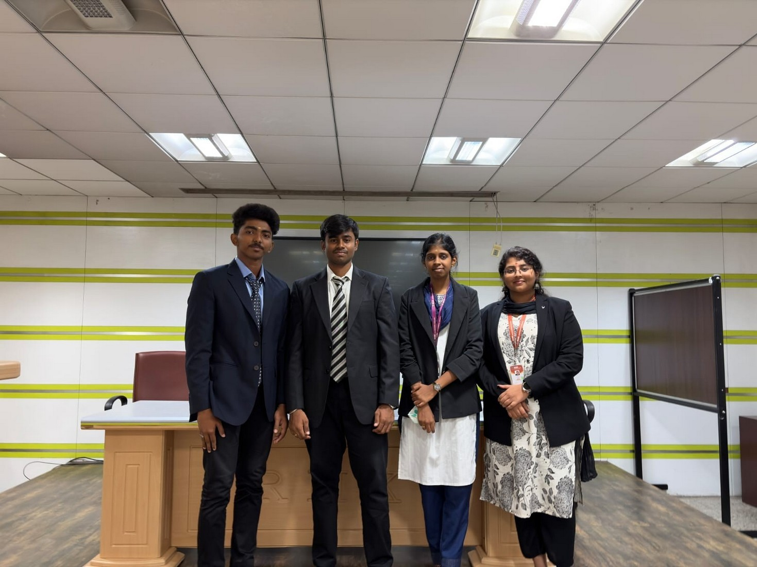

✦ STUDENT REPRESENTATIVES WITH DIGNITARIES & FACULTY ✦
Student representatives with dignitaries and faculty coordinators during the inauguration programme
📊 OUTCOMES OF THE EVENT
The inauguration programme achieved the following verified academic and institutional outcomes:

Formal Commencement of Activities | Formal commencement of the CSE Student’s Association and CSI Student Chapter activities for the Academic Year 2026–2027.
Engagement with Professional Body | Provided students with the opportunity and structured forum to actively engage in departmental and CSI chapter technical events.
Exposure to Industry Leadership | Afforded students direct exposure to industry perspectives through the Inaugural Address delivered by Chief Guest Shri. Pravin Bhamare.
Recognition of Project Innovation | Recognized and awarded student achievement in applied engineering through the Technical Club Mini Project prize distribution.
Active Student Leadership & Coordination | Empowered elected student representatives to plan, coordinate, and execute co-curricular technical initiatives under faculty mentorship.
📝
ATTENDANCE & PARTICIPATION RECORD
Total Participants: [To be inserted from official attendance record]
Venue: RJ Block Seminar Hall | Mode: Offline / In-Person | Date: 12 August 2026

R.M.K. Engineering College (Autonomous) | Department of CSE | CSI Student Chapter Page 6 of 9

POST- EVENT REPORT
Inauguration of CSE Student’s Association & CSI-Student’s Chapter | 2026–2027
📸 PHOTOGRAPHIC DOCUMENTATION
Official event photographs documenting the inaugural ceremony and proceedings at RJ Block Seminar Hall:
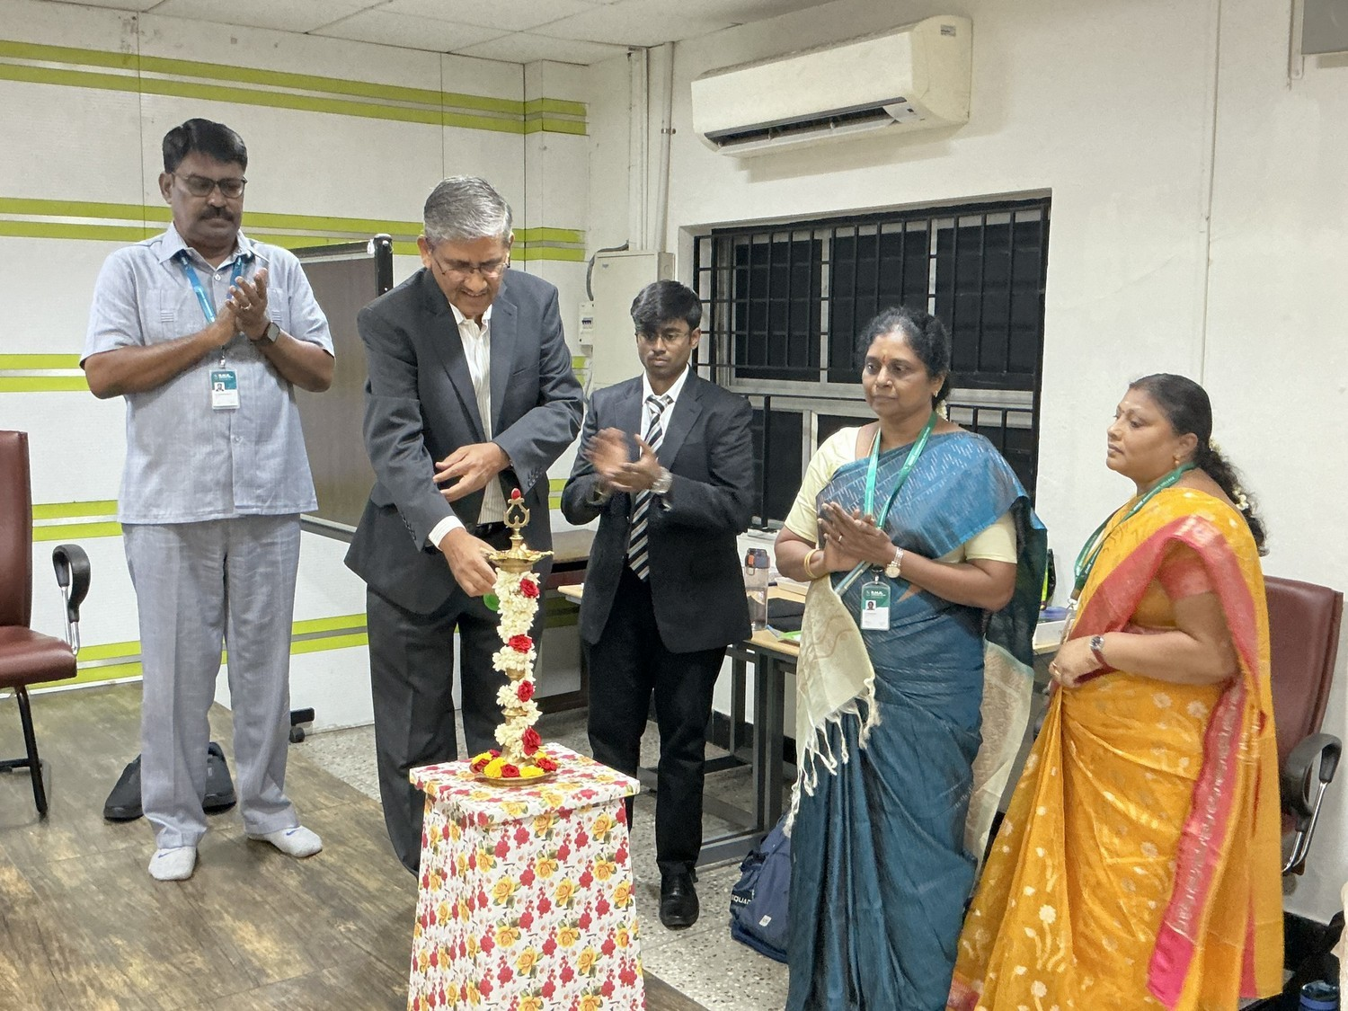
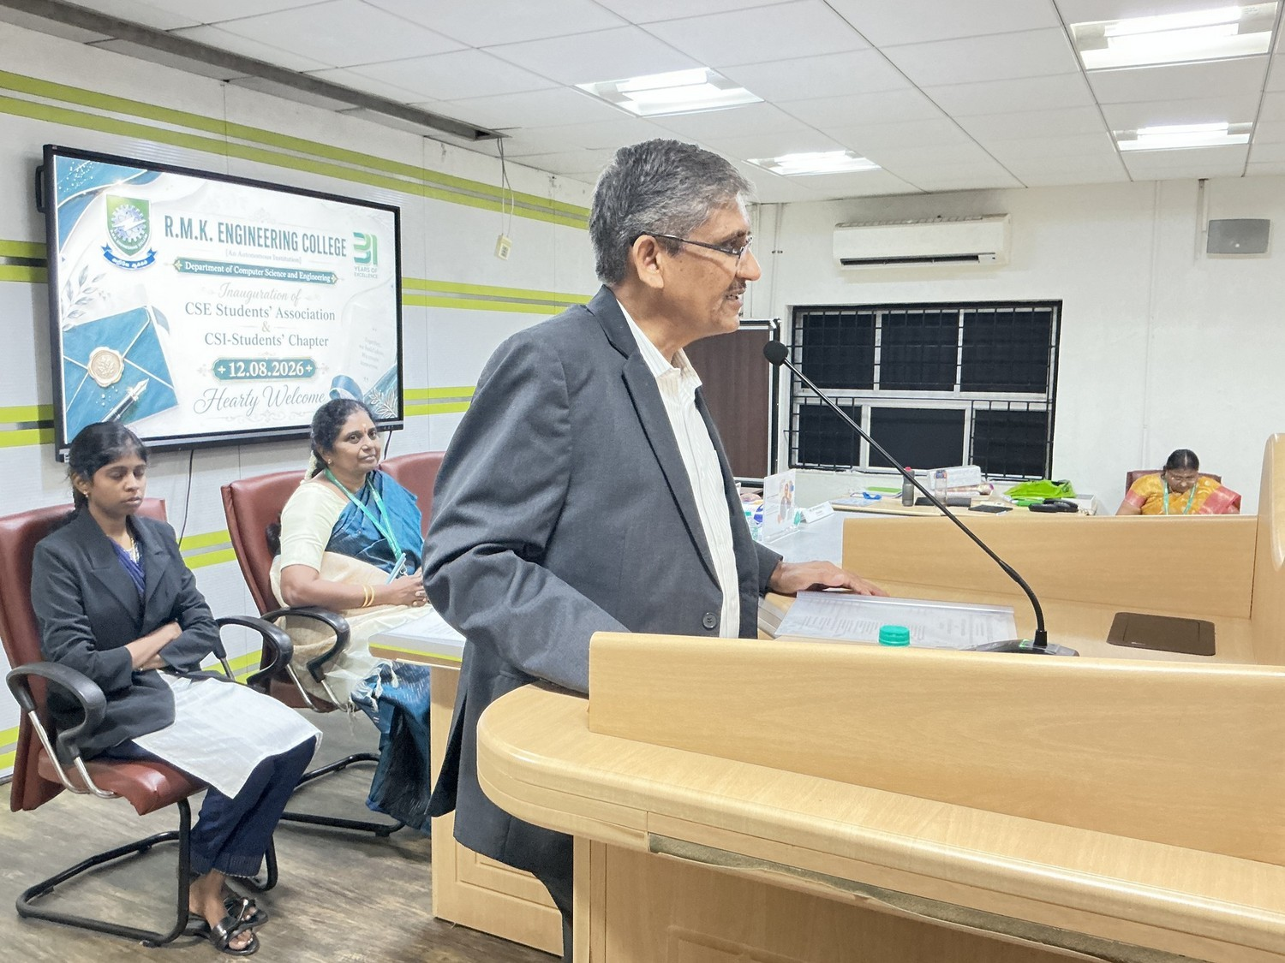

✦ PHOTO 1 — INAUGURATION CEREMONY & DAIS ✦
Dignitaries on the dais during the inauguration ceremony at RJ Block Seminar Hall

✦ PHOTO 2 — PRESIDENTIAL ADDRESS & CEREMONY ✦
Presidential address and assembly during the formal inaugural proceedings

R.M.K. Engineering College (Autonomous) | Department of CSE | CSI Student Chapter Page 7 of 9

POST- EVENT REPORT
Inauguration of CSE Student’s Association & CSI-Student’s Chapter | 2026–2027
📸 PHOTOGRAPHIC DOCUMENTATION (CONTINUED)
Official event photographs documenting the inaugural address and prize distribution ceremony:
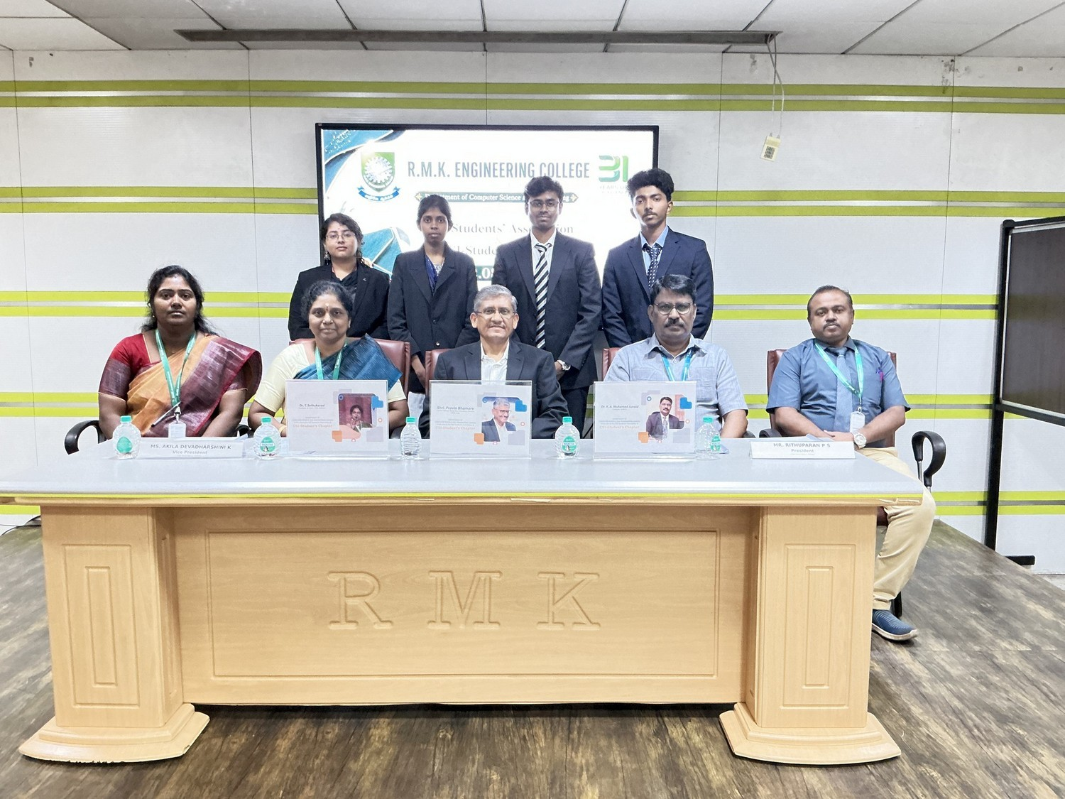
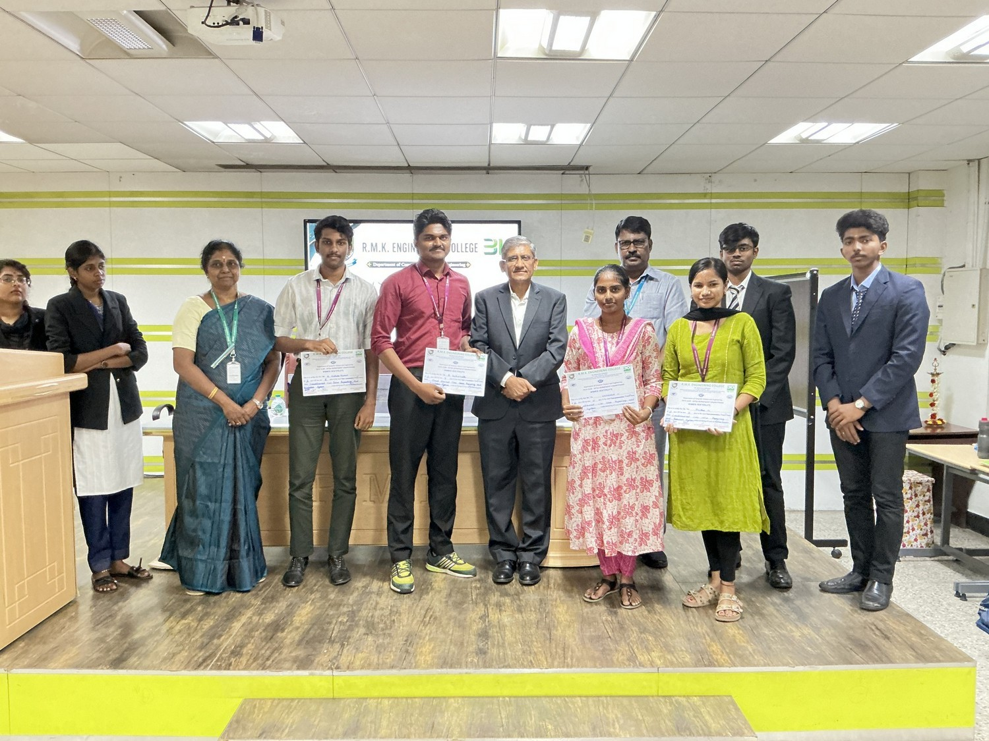

✦ PHOTO 3 — INAUGURAL ADDRESS BY CHIEF GUEST ✦
Shri. Pravin Bhamare, Global Delivery Head, TCS, delivering the Inaugural Address

✦ PHOTO 4 — PRIZE DISTRIBUTION & FELICITATION ✦
Prize distribution recognizing Technical Club Mini Project competition prize winners

R.M.K. Engineering College (Autonomous) | Department of CSE | CSI Student Chapter Page 8 of 9

POST- EVENT REPORT
Inauguration of CSE Student’s Association & CSI-Student’s Chapter | 2026–2027
📝 CONCLUSION
The Inauguration of the CSE Student’s Association and CSI-Student’s Chapter for the Academic Year 2026–2027 was successfully conducted on Wednesday, 12 August 2026 at the RJ Block Seminar Hall,
R.M.K. Engineering College. The ceremony was graced by Shri. Pravin Bhamare, Global Delivery Head, Tata Consultancy Services (TCS), India, as the Chief Guest, who delivered the Inaugural Address. The function was presided over by Vidya Ratna Shri. R. S. Munirathinam, Founder-Chairman, R.M.K. Group of Institutions, with the presence of management trustees, advisors, principal, and faculty members.
The programme formally inaugurated the student association and CSI student chapter, commenced the calendar of co-curricular technical activities, and recognized student achievements through the Technical Club Mini Project prize distribution. The proceedings concluded with the Vote of Thanks proposed by the student Joint-Secretary and the singing of the National Anthem.
Prepared for Official CSI Documentation & Archival:
CSI STUDENT CHAPTER | DEPARTMENT OF COMPUTER SCIENCE AND ENGINEERING
R.M.K. ENGINEERING COLLEGE (AUTONOMOUS)
R.S.M. Nagar, Kavaraipettai – 601 206, Gummidipoondi Taluk, Thiruvallur District

Dr. Mohanaprakash T A  ASP & Coordinator  CSI Student Chapter |  | Dr. T. Sethukarasi  Professor & HoD – CSE  Department of CSE |  | Dr. K. A. Mohamed Junaid  Principal  R.M.K. Engineering College

— End of Report —

R.M.K. Engineering College (Autonomous) | Department of CSE | CSI Student Chapter Page 9 of 9

